- Tên và phân loại:

- Mục đích, ý nghĩa:
- Use sharing to support large numbers of fine-grained objects efficiently.
- Động lực sử dụng:
- Flyweight - shared object can be used in multiple contexts concurrently
• Independent object – cannot tell whether sharable
• Cannot make assumptions about context
• Intrinsic state – does not depend upon context stored by flyweight
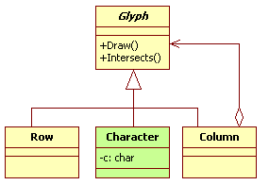
- Khi nào sử dụng:
- An application uses a large number of objects
- Storage costs are high because of the sheer quantity of bjects
- Most object state can be made extrinsic
- Many groups of objects may be replaced by relatively few
shared objects once extrinsic state is removed
- The application doesn't depend on object identity. Since
flyweight objects may be shared, identity tests will return true
for conceptually distinct objects
- Cấu trúc
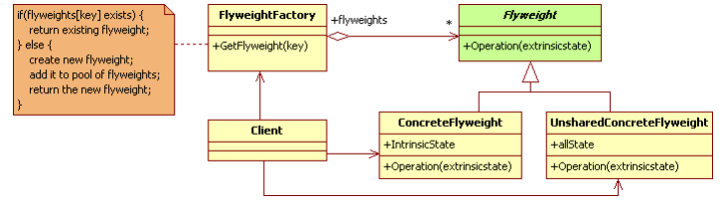
- Các thành viên - Sự cộng tác
- Flyweight
• Declares an interface through which flyweights can receive and act on extrinsic
state
- ConcreteFlyweight
• Implements the Flyweight interface and adds storage for intrinsic state, if any
• A ConcreteFlyweight object must be sharable. Any state it stores must be intrinsic;
that is, it must be independent of the ConcreteFlyweight object's context
- UnsharedConcreteFlyweight
• Not all Flyweight subclasses need to be shared
• The Flyweight interface enables sharing; it doesn't enforce it. It's common for UnsharedConcreteFlyweight objects to have ConcreteFlyweight objects as children at some level in the flyweight object structure.
- FlyweightFactory
• Creates and manages flyweight objects
• Ensures that flyweights are shared properly. When a client requests a flyweight, the
FlyweightFactory object supplies an existing instance or creates one, if none exists
- Client
• Maintains a reference to flyweight(s)
• Computes or stores the extrinsic state of flyweight(s)
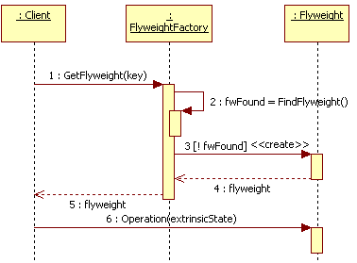
- Các hệ quả mang lại:
- The reduction in the total number of instances that comes from
sharing
- The amount of intrinsic state per object
- Whether extrinsic state is computed or stored
- Chú ý liên quan đến cài đặt:

- Hệ thống thực tế

- Mẫu liên quan
- The Flyweight pattern is often combined with the Composite
pattern to implement a logically hierarchical structure in terms
of a directed-acyclic graph with shared leaf nodes
- It's often best to implement State and Strategy objects as flyweights

